# The Placeholders- Spec Document

# Problem statement

[How might we…]

How might we help educators teach visual learners?

# Summary

[Pitch on why this app is needed. What user needs is the app going to address? Why is the app worth building? What differentiates it?]

The Overall Need: This app provides a space *exclusively* for college professors to engage with each other, promoting a community where professors can learn and share visual content with those of the same professional background.

Consumer Summary

**This app is going to address the need for professor-endorsed visual content to inspire new teaching ideas among other professors.**

***Professor-endorsed = professor-used-tested-and-recommended tools.

Creator Summary

**This app is going to address the need for professor-endorsed feedback on visual content to allow for the distribution of new ideas.**

This app is going to address the need for a platform where professors can share visual teaching tools in a more comfortable and exclusive/safe environment, so consumers can trust what content they consume (and creators create for a credible/more specialized audience ).

***The difference between Youtube/etc. and our app is who can post***

This app is worth building because it addresses a specific, legitimate, need for creative visual learning techniques in the classroom.

**This app is worth building because there is a lack of professor-specific resources for collaborating and sharing ideas on a mobile platform, and this app creates new opportunities for information sharing and network building.**

There is no other app that target’s this need as ours will.

--------------------------------------------------------------------------------------------------------

# Customer profile

[Recap your target audience]

Our target audience is professors.

# Goals

[What are you improving in the customers life? What is the success outcome you’re looking for?]

We are improving the way professors share (and learn) visual learning tools/curriculums in a wider spectrum.

The success outcome of this would be the formation of a community that views, shares, and discusses these visual learning tools/curriculum within our app.

The goal is to make professors engage with and contribute their own ideas on visual content that will improve their classrooms.

# Prioritized user stories

[P0 – must have, key to value prop of MVP] [P1 – nice to have] [P2 – stretch goals]

As a _______, I want __________ so that ____________

**Big Picture User Story: As a professor, I want new ideas to teach using visual learning techniques, so that I can accommodate visual learners in my classrooms.**

**P0**

**P0-** Item 1: Create an account (Welcome/opening page)

**P0-** Item 2: Explore/follow topics (such as: area of study; school; state; etc;)

**P0-** Item 3: Content feed (scroll)

**P0-** Item 4: Create a post- As a biology professor, I want to share a cell cycle diagram that I used   
**P0**- Item 5: Comments

**P0-** Item 6: Search engine (Keyword)

**P0-** Item 7: export content

**P0-** Item 9: sign in (and log out)

**P0-** Item 10: user profile—As a cs professor, I want to be able to see

**P0**- Item 11: professor verification

**P0-** Item 18: Connect/Follow Other Teachers

**P1**

**P1-** Item 8: directed message

**P1**- Item 12: badges/achievements

**P1-** Item 13: Reactions/Likes

**P1-** Item 14: Bookmarks/Favorites/Collections Page

**P1**- Item 16: Recommendations

**P1-** Item 17: Settings

**P1**- Item 19: Communities

**P1**- Item 20: Advanced

**P2**

**P2?**- Item 15: Hashtags

**Pages:**

1. Opening/Sign in/Sign up Page
2. One-Time Follow topics/professors page
3. Home Feed Page/Search Bar/Download
4. User Profile Page
5. Post content page

Explore page: Head bar, Comment, Reactions/like (P2)

Notes on things to consider adding:

Advanced search

General:

As a data science professor, I want new ideas to teach using visual learning techniques, so that I can accommodate visual learners in my classrooms. {learn different contents from other professors’ post}

-------------------------------------

1. As a professor who wants to put together a lesson plan, I want to ask questions about visual content that I need to help teach material to my students. {forum- ask for support from the community}



1. As a CS professor who doesn’t have visual content to teach algorithms, I want to look through new types of visual content so that I can search for what works best for me. {search engine}



1. As a Chinese professor, I want to share my expertise in teaching this language using visuals with other professors, to make learning Chinese more attainable for a wider audience. {share learning content}



1. As a mathematics professor, I want to make my classroom more enjoyable for my students so that my students are more engaged and interested in the lectures. {forum-



1. As a music professor, I want to make connections with other institutional music professors so that I could discuss with them how to improve my class curriculum. {networking}
2. As a new physics professor, I want to be able to access to a professor for individualized advice, so that I can have a second opinion on my method of teaching.
3. As a
4. As a history
5. As a Math professor, I want to
6. As a

P0 Cassie

As a data science professor, I want new ideas to teach using visual learning techniques, so that I can accommodate visual learners in my classrooms.

* Item 1: As a professor who wants to put together a lesson plan, I want to ask questions about visual content I need to help teach material to my students.
* Item 2: As a professor who wants to find new types of visual content, I want to use a search engine categorized by media type + filters for different fields of study and different subjects to
* Item 3: Connect/Follow with other professors
* Item 4: Media feed to see all the new ideas/lessons that the professors I follow are posting

Questions:

* Search: What comes up in it? Professor content, or internet content? Netflix shows?
* Categories organized by “tags”?
* Field of study: math, subject: calculus?

P1 Dave

As a Chinese professor, I want to share my expertise in teaching this language using visuals with other professors and students, to make learning Chinese more attainable for a wider audience.

* Item 1: Post his teaching materials to other professors and students to make Chinese more attainable for a wider audience.
* Item 2: Chance to get more sources and feedback from the online network from the forum.
* Item 3: make more effect to other
* Item 4:

P2 New Teacher or Student

* Item 1: Explore
* Item 2
* Item 3

# UX and work breakdown

[Screens of application with components defined. Higher level of detail for P0 and P1 items. If P2 items come up, the spec can be revisited. User stories broken into tasks. Helpful to include all up app flow]

[Sample – describes controls and navigation, assigned, user story -> tasks

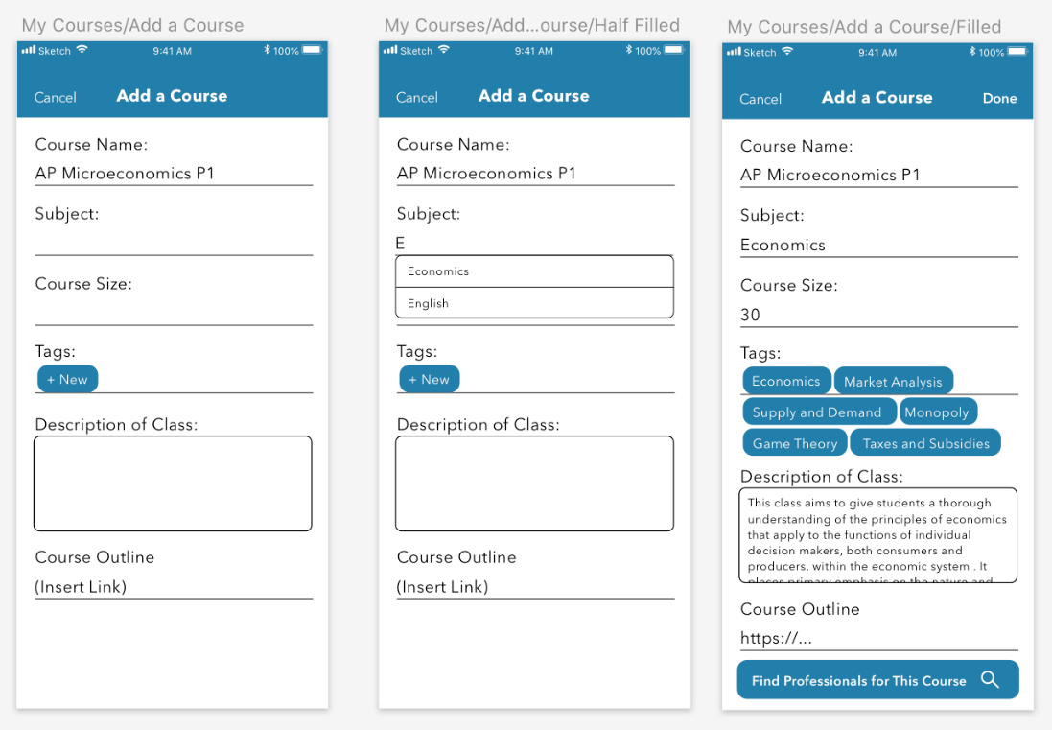

|  |  |
| --- | --- |
| Add a Course - Steve | Cancel: back to dashboard  Done: go to course detail, only show if all must-fills are filled  -----------------------------------------  **Scroll view**   * Textfield: Course Name * Textfield + dropdown: subject * Textfield: course size (integer only) * Tags/attributed text?: allow users to type in and search for tags in database * Textfield (multi-line): description of class * Textfield: linked to the course outline Button: Find Professionals for This Course, linked to a list of Recommended Profiles (probably an image), only shows if all must-fills are filled   Stretch:  Upload button for course outline- upload a pdf to somewhere |

]

# Competitive analysis

[Strengths, weaknesses, threats and opportunities of app]

* Reddit
  + Allows people to communicate and publish their needs. Also, allows users to comment on other people’s regarding the specific topic.
* Youtube
  + They have videos with comment sections and thumbs up
    - But we have student ratings
    - badges that showcase and highlight teacher contributions.
* Khan academy
  + Videos with comment sections and thumbs up and articles.
    - We have more than just videos, articles, pictures, links to to apple-store or anything relevant.
    - It isn't just the same boring sounding guy talking. There are more diverse ideas and teaching methods shown by many different people.

# Future opportunities

[What would be included next? What are other ways to expand the product reach?]

Maybe the professor’s account could be an additionally linked to their LinkedIn Account. Or on some platform because teachers can showcase their unique and creative ideas for visual learning in the classroom to employers.

Having a student view in the future.